

10/25/2024

**SUBMITTED BY: MARYAM ASIF**

**SAP ID: 65490**

**DEPARTMENT: CYBER SECURITY**

**SEMESTER: 1ST**

**SUBMITTED TO: MA’AM FAREEHA**

PROGRAMING FUNDAMENTAL

LAB TASK#8

**QUESTION N0 1:**

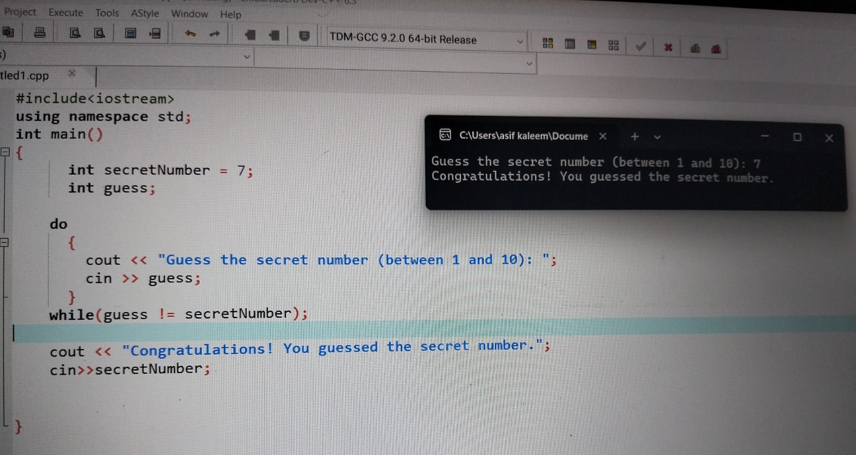

**QUESTION NO 2:**

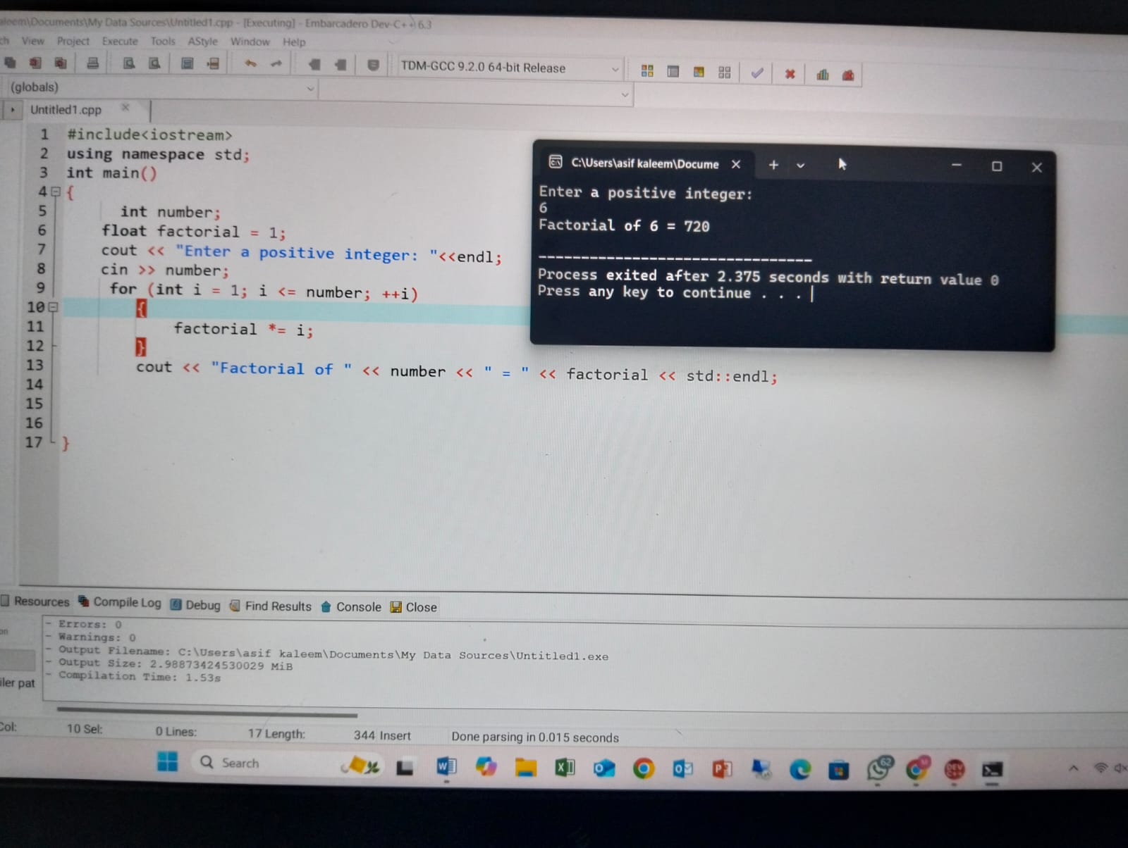

**QUESTION N0 3:**

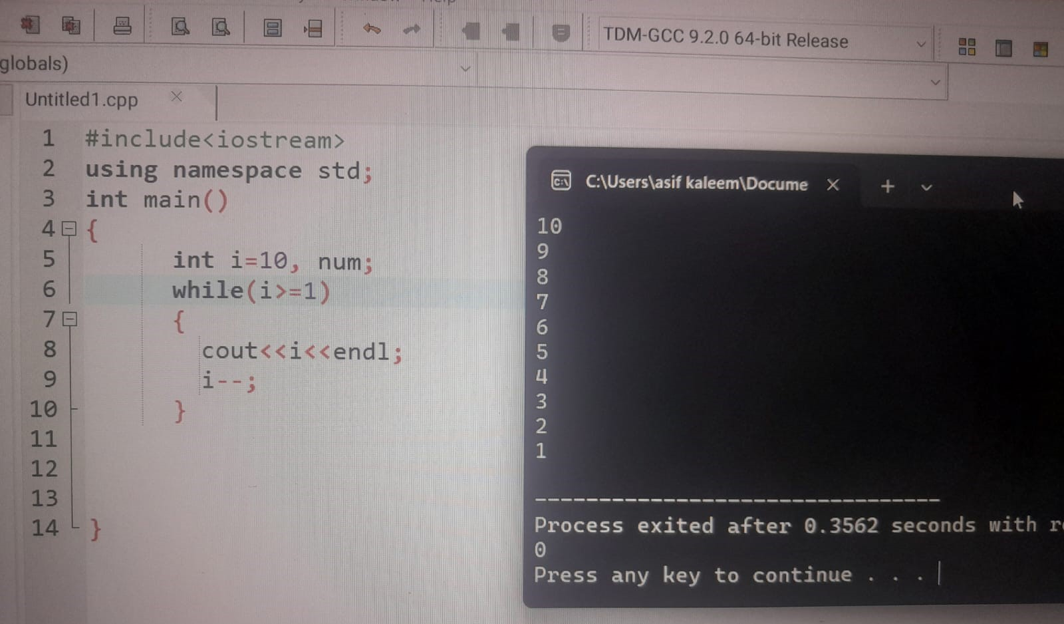

**QUESTION NO 4:**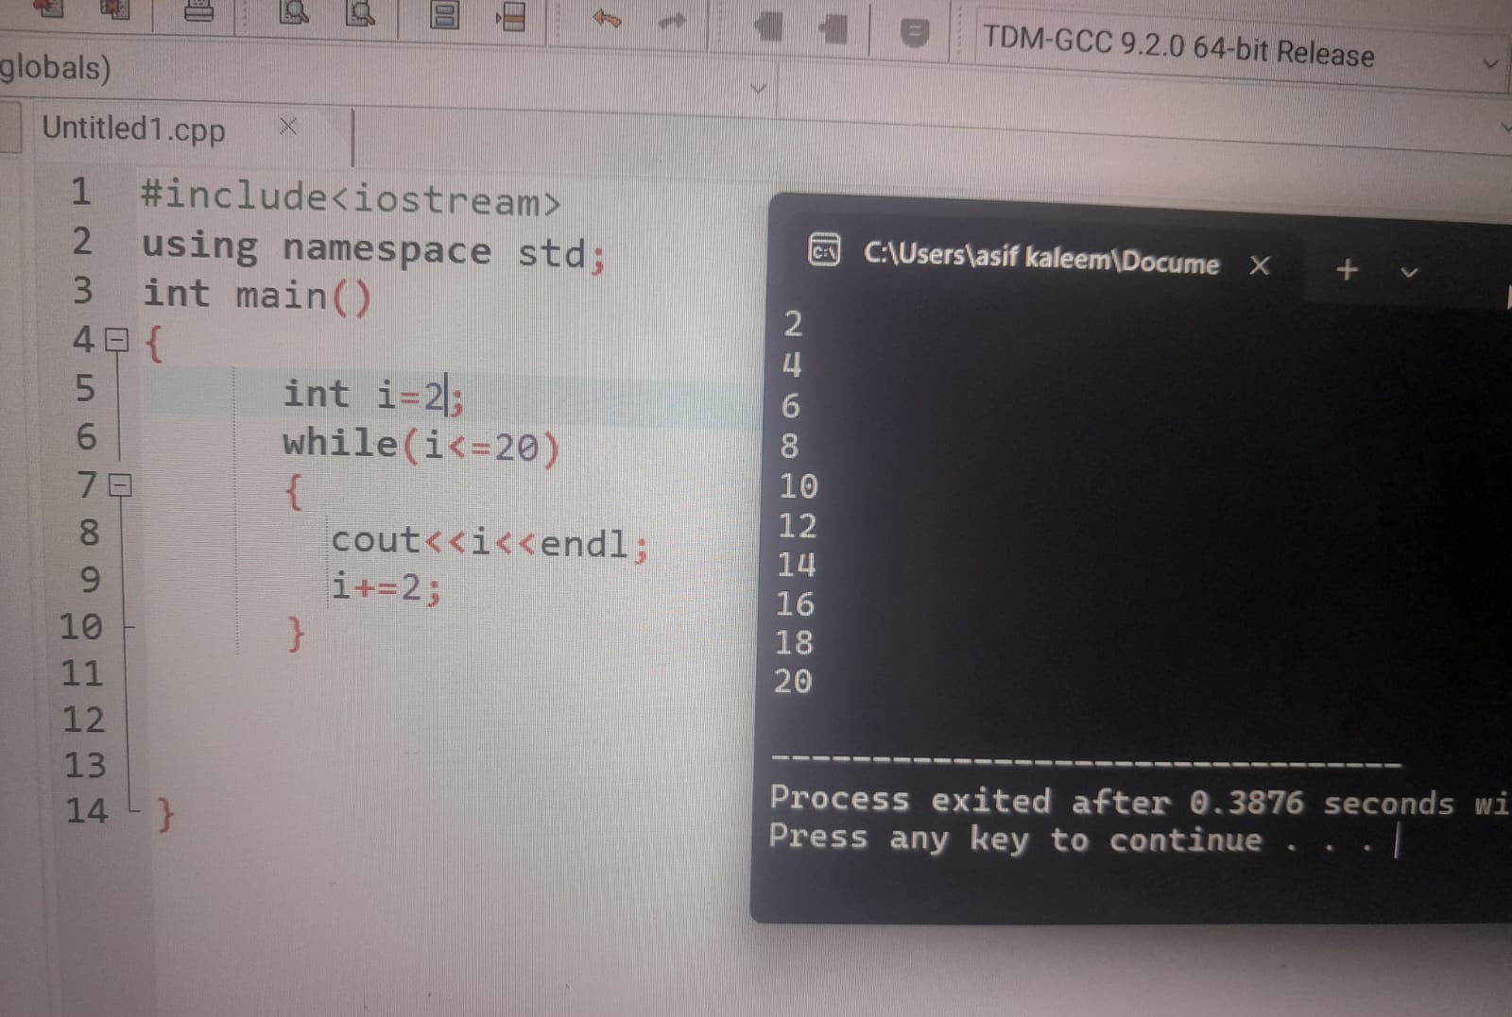

**QUESTION NO 5:**

